**Personal Technical Portfolio Documentation**

**Project** **Description** The Personal Technical Portfolio is a static web application designed to showcase an individual's technical skills, projects, achievements, and experience in a visually appealing and organized manner. It aims to highlight their expertise, demonstrate their coding abilities, and provide a comprehensive understanding of their technical background to potential employers, clients, or collaborators. The goal of this application is to create a visually compelling and professional portfolio that impresses visitors and establishes a strong online presence.

**Technical** **Architecture**

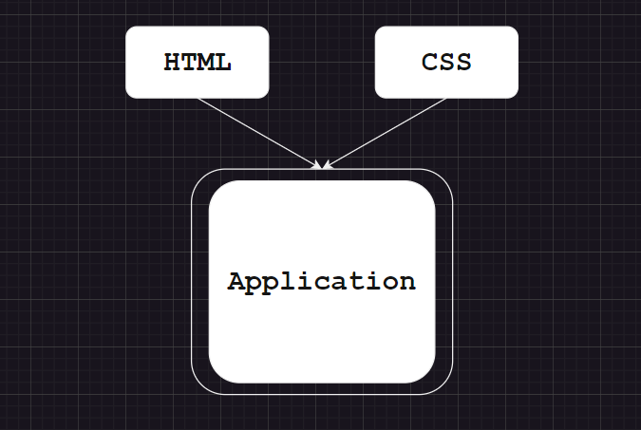

**Pre-requisites**

To complete this project, you will need:

* A code editor (such as Visual Studio Code, Sublime Text, or Atom)
* A web browser
* An internet connection
* HTML and CSS knowledge

**Project** **Objectives** By the end of this project, you will:

* Create a user interface using HTML and CSS to showcase the technical portfolio.
* Design visually appealing and organized sections for skills, projects, achievements, and experience.
* Ensure responsiveness for different screen sizes.
* Optimize the website for fast loading and accessibility.

**Project** **Flow** To accomplish the objectives, we will complete the following activities:

**Milestone** **1**: Set up the project structure

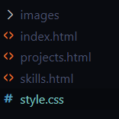

* Create a new project folder for the Personal Technical Portfolio Website.
* Inside the project folder, create the following files/folders:
  + index.html
  + projects.html
  + skills.html
  + style.css
  + images/ (optional)

**Milestone** **2**: Design and implement the user interface

* Open index.html in your code editor.
* Set up the basic HTML structure.
* Design the layout and structure of the user interface using HTML elements and CSS classes.
* Create visually appealing sections for skills, projects, achievements, and experience, showcasing your technical expertise and accomplishments.
* Apply styles to the UI elements using CSS in style.css.
* Link style.css to index.html.

**Milestone** **3**: Create sections for introduction, skills, projects, achievements, and experience

* Divide the webpage into different sections to showcase your skills, projects, achievements, and experience.
* Design and implement the layout and structure of each section using HTML elements and CSS.
* Add relevant content, such as project descriptions, code snippets, technologies used, and links to GitHub repositories or live demos.
* Create a navigation bar with links to "About", "Projects", "Skills", and "Contact".
* Update the navigation links to direct to the respective pages (about.html, projects.html, skills.html, and contact.html).

**Milestone** **4**:

Apply CSS styles

* Enhance the visual appeal of the user interface using CSS styles.
* Apply appropriate colors, fonts, and spacing to create a visually appealing design.
* Use CSS media queries to ensure responsiveness across different screen sizes.

**Milestone** **5**

* Ensure that the website is responsive and displays well on different devices and screen sizes.
* Test accessibility and make necessary adjustments to comply with accessibility standards.
* Optimize the website for fast loading by minifying CSS files, optimizing image sizes, and utilizing caching techniques.

**Output**

* The output of this project will be a static web application that showcases your personal technical portfolio in a visually appealing and organized manner.
* It will include sections for skills, projects, achievements, and experience.
* The navigation bar will have links to "About", "Projects", "Skills", and "Contact".
* Clicking on the "Projects" link will take the user to projects.html.
* Clicking on the "Skills" link will take the user to skills.html.

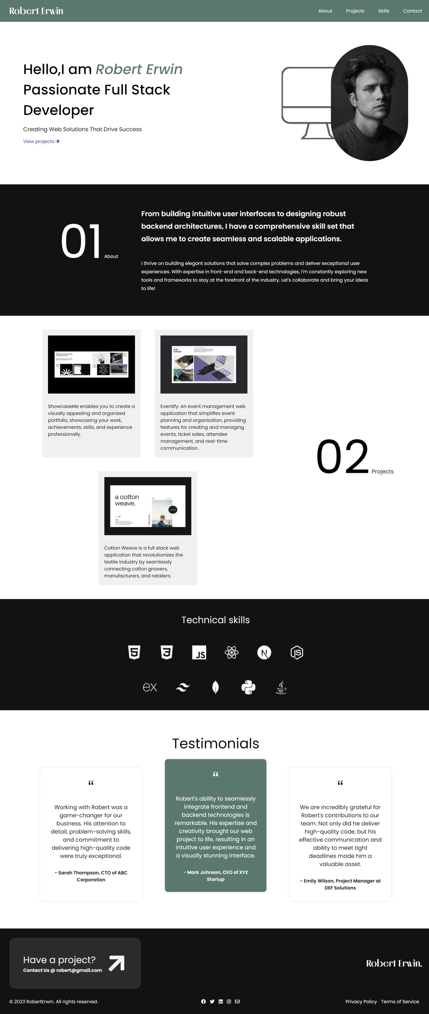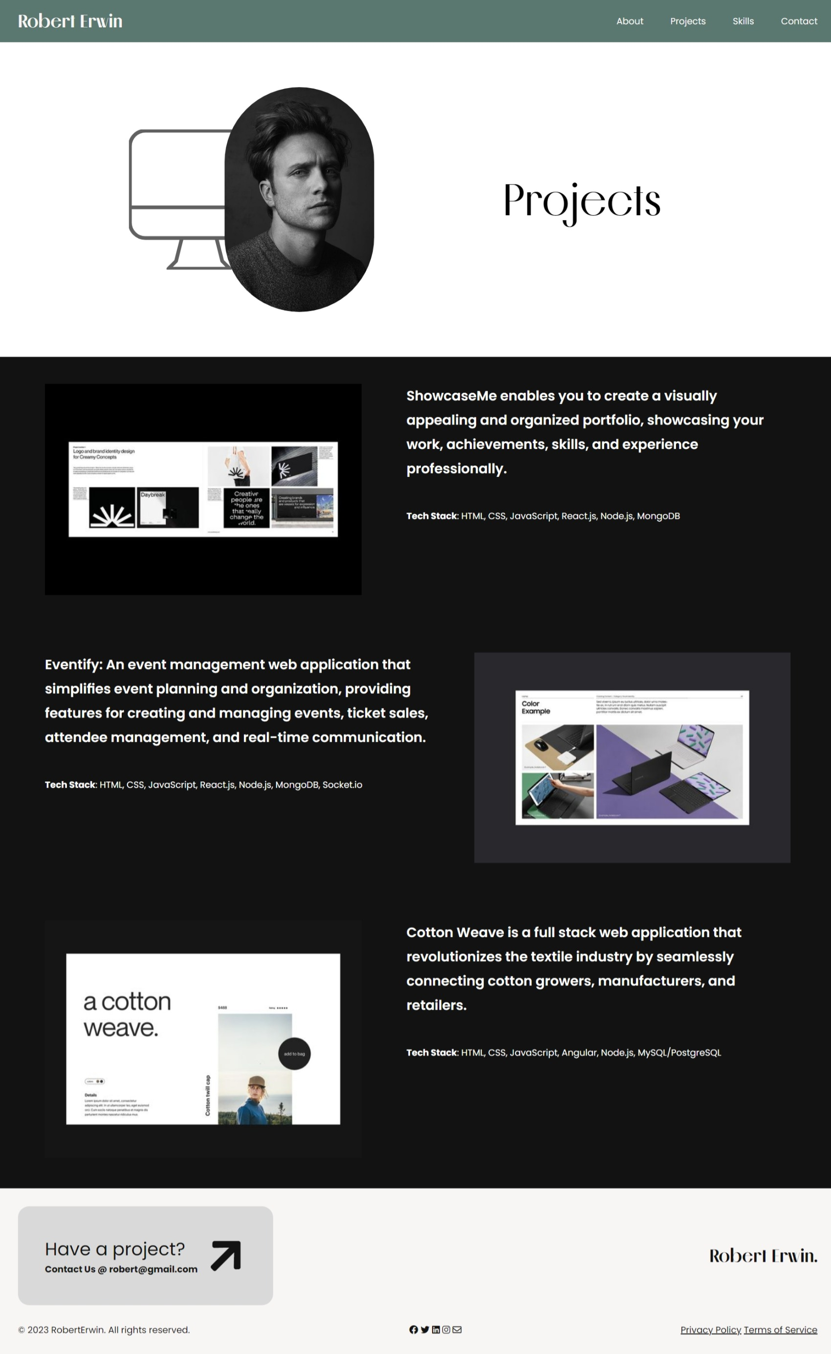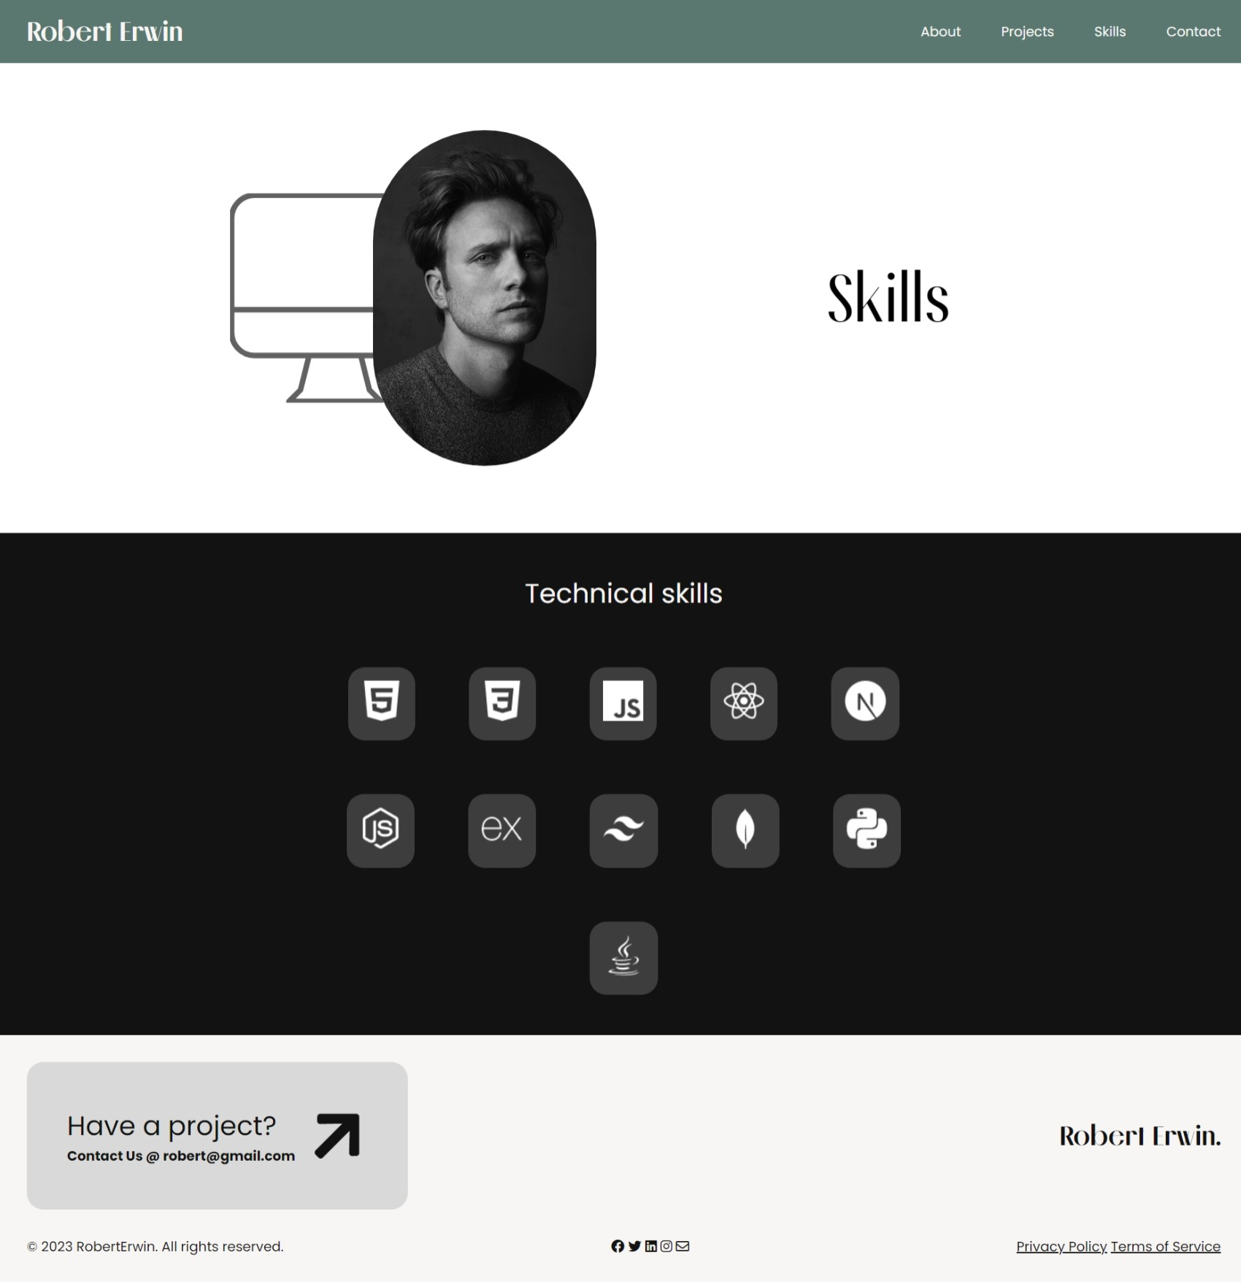

**Video** **explanation**- [link](https://drive.google.com/file/d/1FudkFzIt269AP_QJL_bbrjCcgyUPpKeN/view?usp=drive_link)

**Conclusion**

The Personal Technical Portfolio Website is a static web application that effectively showcases an individual's technical skills, projects, achievements, and experience. By designing visually appealing sections and applying CSS styles, it creates a professional and engaging portfolio that impresses visitors. The optimized website ensures responsiveness, accessibility, and fast loading, providing a seamless browsing experience for potential employers, clients, or collaborators.